

Project on

# MERN SOCIAL MEDIA APP

2021-2022

Submitted By -

Sanket Dnyandev Jadhav



**D****eccan Education Society’s** **Fergusson College (Autonomous), Pune**

**Department Of Computer Science**

**CERTIFICATE**

This is to certify that the project entitled

“MERN SOCIAL MEDIA APP” submitted by

1. Sanket Dnyandev Jadhav 21567

in partial fulfillment of the requirement of the completion of M.Sc.(C.S)-I [Semester-II], has been carried out by them under our guidance satisfactorily during the academic year 2021-2022.

Place: Pune Date: / /2022

**Head of Department**

**Department Of Computer Science Fergusson College (Autonomous), Pune**

**Project Guide:**

1. **Prof. Aparna Vaidhyanathan**

**Examiners Name Sign**

**1.**

**2.**

### INDEX

* 1. College Certificate
  2. Acknowlagement
  3. Introduction
  4. Objective
  5. Scope 6.Features 7.Feasibility Study
     1. Economic Feasibility
     2. Operational Feasibility
     3. Technical Feasibility 8.Analysis and Design Diagram 9.Implementations

A.Output Screens

1. Conclusion
2. Reference

**Acknowledgement:**

I have taken efforts in this project. However, it would not have been possible without the kind support and help of many individuals and organizations. I would like to extend my sincere thanks to all of them.

I am highly indebted to Prof. Aparna Vaidhyanathan for their guidance and constant supervision as well as for providing necessary information regarding the project &

also for their support in completing the project.

I would like to express my gratitude towards my parents & member of Fergusson College Fy.M.Sc. (Computer Science) for their kind co-operation and encouragement which help me in completion of this project.

I would like to express my special gratitude and thanks to industry persons for giving me such attention and time.

My thanks and appreciations also go to my colleague in developing the project and people who have willingly helped me out with their abilities.

By

Sanket Jadhav

# Introduction

Social media is an internet-based form of communication. Social media platforms allow users to have conversations, share information and create web content. There are many forms of social media, including blogs, micro-blogs, wikis, social networking sites, photo-sharing sites, instant messaging, video- sharing sites, podcasts, widgets, virtual worlds, and more.

Billions of people around the world use social media to share information and make connections. On a personal level, social media allows you to communicate with friends and family, learn new things, develop your interests, and be entertained. On a professional level, you can use social media to broaden your knowledge in a particular field and build your professional network by connecting with other professionals in your industry. At the company level, social media allows you to have a conversation with your audience, gain customer feedback, and elevate your brand.

The term social media encompasses a large of communication ,social networking and community tools that are consistently being upload and changed.The wide varienty of social media platform has become more popular among a broad spectrun of organization.The notation of social media may bring to mind many of the larger,perhaps well-known platform such as Facebook,Twitter,Linkedln, as well as the general term Blog.

There are very popular among young people , are becomig prelevent due to their nature to meet the needs of individuals towards socialization.Their nature that focuses on individuals , started to shape users process of interaction and has become one of the important elements of the daily life.The high number of people joining social networks, which defined as programs that ease the interaction betweeen individuals and groups,provides various opportunities for social feedback and support the information of tangled social relation

# OBJECTIVES

The main objective of the project on social media app is to manage the details of User Profile, Post .It can manages all the information about profile. The purpose of the project is to build an application program to reduce the manual work for managing online interaction

# SCOPE

It may help collecting perfect management in details. In a very short time, the collection will be obvious, simple and sensible. It will help a person to know the management of passed year perfectly and vidly.It also helps in current all works relative to social media app. It will be also reduced cost of collecting the management and collection procedure will go on smoothly.

# FEATURES

* User accounts to control the access and maintaion security
* It contains better storage capacity
* Accuracy in work
* Access of any information individually
* Work becomes very speedy
* Easy to update information

# FEASIBILITY STUDY

After doing the project social media app ,study an analyzing all the existing or required functionalities of the system,the next task is to do feasibility study for the project.

## ECONOMIC FEASIBILITY

We are developing a project for practice purpose that will give us a lot of cofidance to build a bigger project in future.Hence the economical feasibility is very good.

## OPERATIONAL FEASIBILITY

No doubt the proposed system is fully GUI based that is very user friendly and all inputs to be taken all self-explanatory even to layman.

## TECHNICAL FEASIBILITY

In this aspect of feasibility we consider the tecnical equipment required for developement.For this we required various hardware equipment such as computer ,Mern stack tecnology i.e Nodejs,Express,MongoDB.

# ANALYSIS & DESIGN DIAGRAM

### Activity Diagram:

An activity diagram shows the flow from activity to activity. An activity is an ongoing non-atomic execution within a state machine. Activities ultimately result

in some action, which is made up of executable atomic computations that result in a change in state of the system or the return of a value .



Login to App

Filling the form

Invalid

Valid

Create Account

New Post

Followers

Following

END



Logout From the app

### Class Diagram

Class diagrams are the blueprints of your system or subsystem. You can use class diagrams to model the objects that make up the system, to display the relationships between the objects, and to describe what those objects do and the services that they provide. Class diagrams are useful in many stages of system design.

User

[Not supported by viewer]

[Not supported by viewer]

Post

postID - int caption - string postImage - string likes - int comment - string

ownerImage - string ownerName - string ownerId - string

+setliked()

+setLikedUer()

+setCommentValue()

+setCaptionvalue()

Search

Name - string

+setName()

New Post

image - string caption - string

+setImage()

+setCaption

### 2.Data Flow Diagram

A data-flow diagram (DFD) is a way of representing a flow of a

data of a process or a system (usually an information system). The DFD also provides

information about the outputs and inputs of each entity and the process itself.

### Zero level DFD

N



MERN Social Media App

User Management

ew Post Management

Profile Management

Post Management

### First Level DFD

N



MERN Social Media App

User Management

ollowing Management

ollowers Management

Profile Management

Check User Details

ew Post Management

Post Management

**Second Level DFD**



User

Login To System

Check Credentials

Manage Modules

Manage Following

Manage Followers

Manage Profile

Manage Post

Manage New Post

**Usecase Diagram**

A use case diagram is a diagram that shows a set of use cases and actors and relationships.A use case describes a sequence of actions that provide something of measurable value to an actor and is drawn as a horizontal ellipse an actor is a person, organization, or external system that plays a role in one or more interactions with your system.

Includes

Login

New Post

Search

User

Followers

Following

Logout

Like

includes Includes

Dislike

Comment

Includes

Search by name

Includes

Followers List

Includes

Following List

**IMPLEMENTATIONS**

Login Page

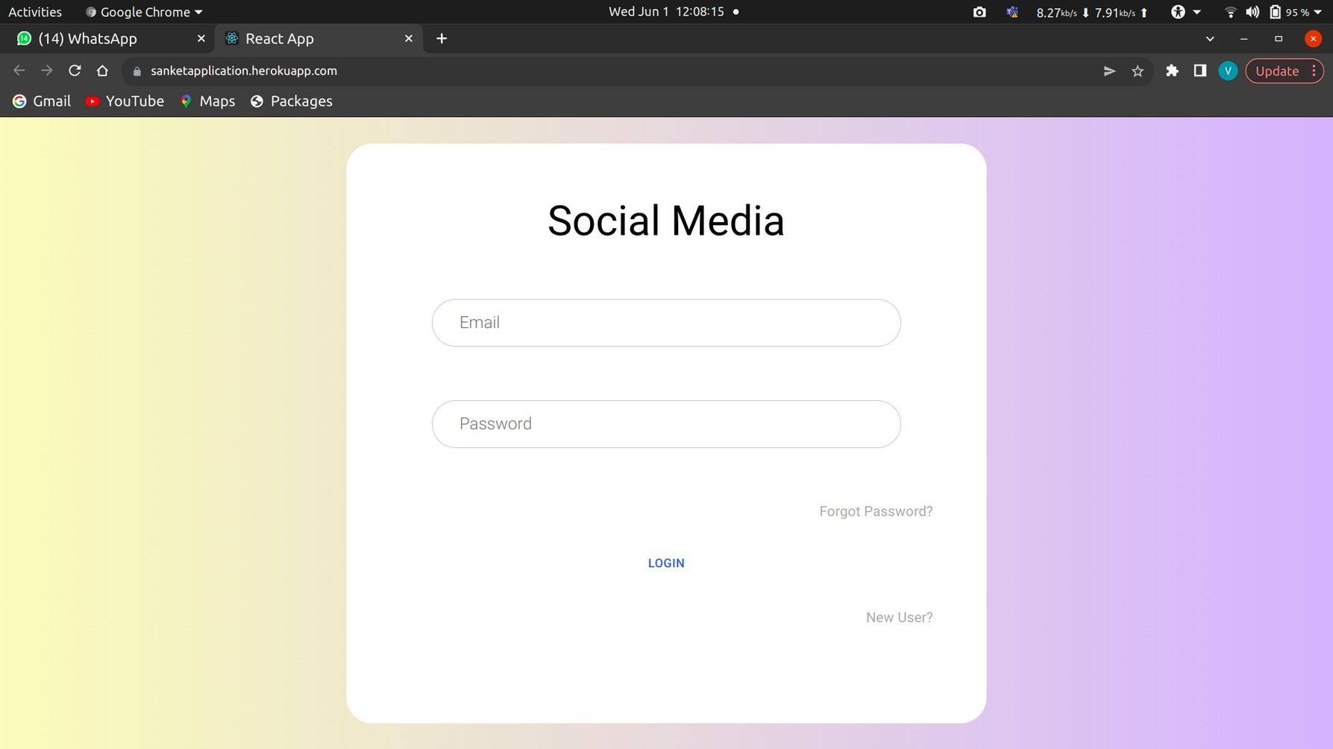

SignUp page

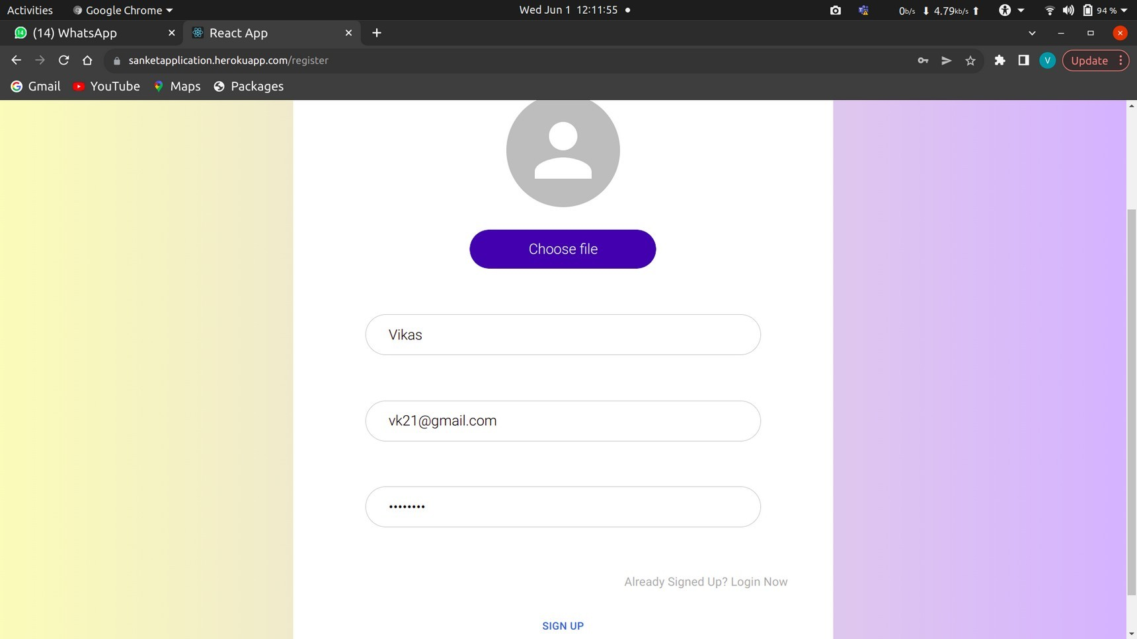

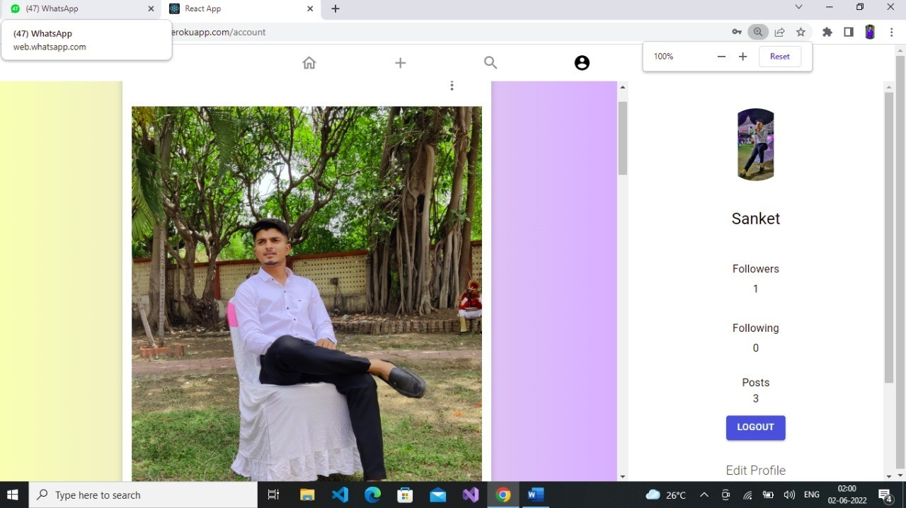Home Page

New Post

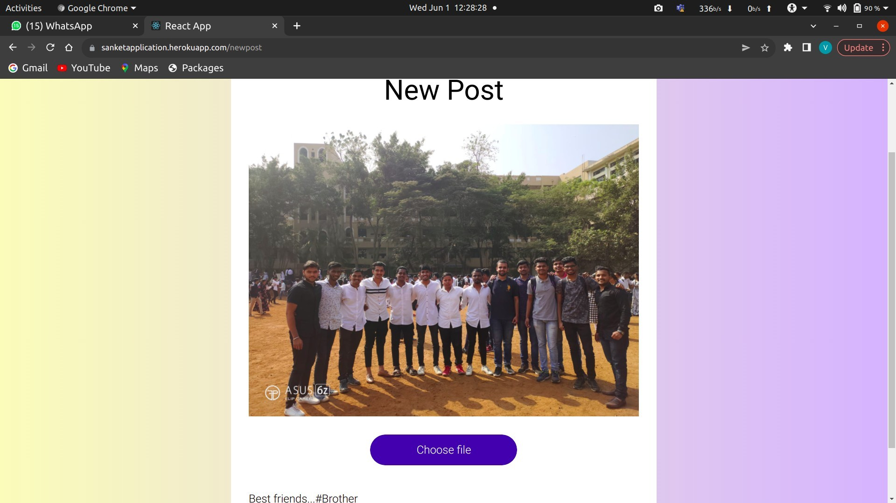

Search Screen

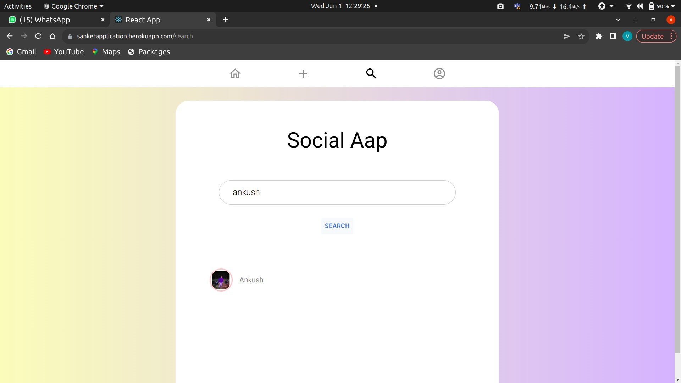

Followers Screen

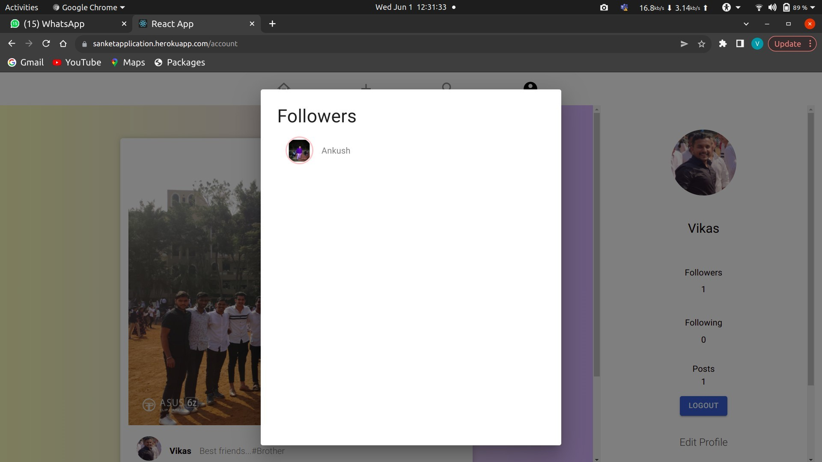

Update profile Screen

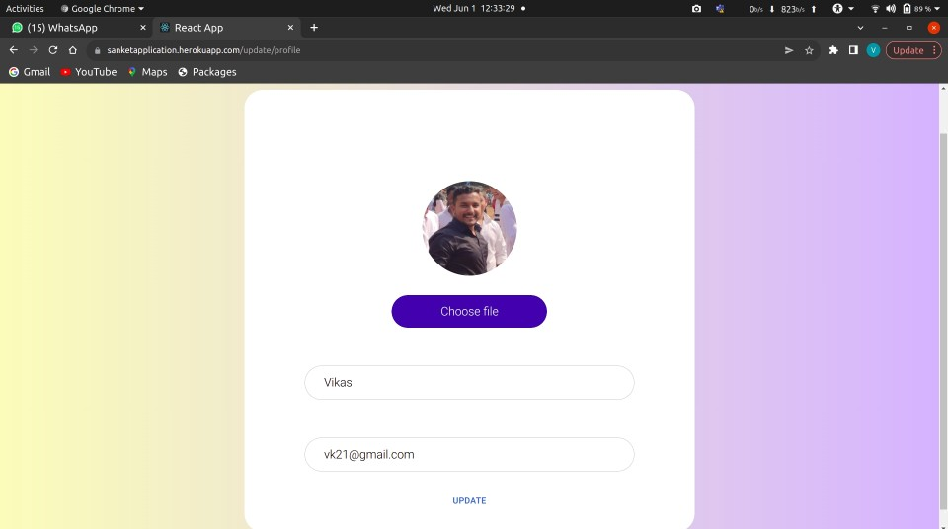

Social Aap

## CONCLUSION

As in face-to-face communication, disagreements are inevitable in virtual environments when there is a human factor. However, minimisation of the problems is possible by managing the process properly and making out the possible problems. However, social networks are applications that started to become a part of education in the natural flow of daily lives. In the studies

on these applications, generally, minimisation of the problems and use of their potential to support education processes are emphasized. Also, in this

research, it was mentioned that they provide unstructured learning environment and can be used as effective tools in education , Yet it is early to know what impact the social application, which has an important place in the daily lives of young people and has the qualities to be recognised as social network,

will have on education. As a result of this study, it is determined that the application has a positive impact on success and its use is welcomed substantially.

## REFERENCES

1. <https://www.mongodb.com/mern-stack>
2. <https://www.mongodb.com/products/compass>
3. <https://cloudinary.com/>
4. [https://www.w3schools.com](https://www.w3schools.com/html)
5. <https://www.diagrameditor.com/>
6. https://www.heroku.com/